Rehab Building At Sion.

1. Project Information
- Project Name: Prince Residency I & II
- Location: Sion- Wadala
- Plot Area: 3400 sq.mt.
- Built-up Area: 250000 sq.ft.
- Project Type: Residential redevelopment
- Client/Developer: Transindia Group
- Status: Tower 1 completed

2. Project Overview
Prince Residency is a residential redevelopment comprising high-rise and mid-rise residential wings. The project focuses on efficient planning, a contemporary façade and a unified architectural identity. Its clean elevation and strong vertical composition create a prominent presence within the urban surroundings.

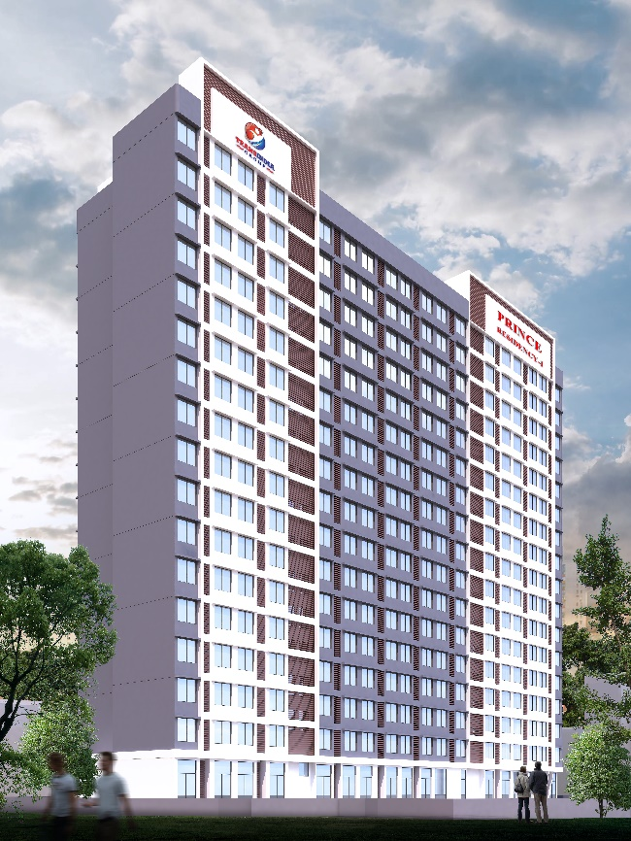
Image 4.
Image 3.
Image 1.
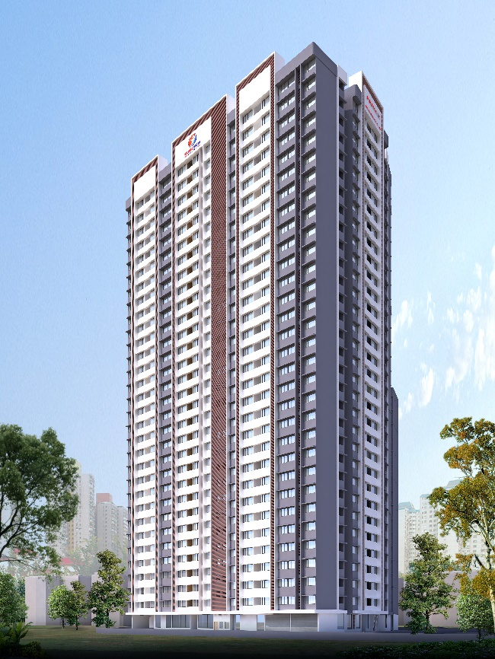
Image 2.
